

 

**NAME OF COURSE: PYTHON ADVANCE**



Name of the project: Cricket Academy

Submitted by: Baffin Thomas. T

Guided by: Mrs. Shalini



**INDEX**

|  |
| --- |
| ABSTRACT  REQUIREMENTS  PROGRAM  OUTPUT  CONCLUSION |

**ABSTRACT**

Cricket Academy is a project built using the Django web frame and also Db sqlite3 database for authentication. I have developed the project using in PyCharm Python’s official software developing platform, designed to streamline the cricket academy process.

In today’s fast-paced world, cricket organizers and attendees need a seamless and user-friendly platform to cricket and academy effortlessly. This project aims to provide a solution that caters to the needs of event organizers and attendees by offering a user-friendly web application.

Key features of the project include user registration, Cricket Academy. User register and dates are stored in database. Cricket organizers can create and cricket academy with ease and monitor their event. Attendees can browse all details about cricket venue. The system ensures data security and privacy by implementing robust authentication and authorization mechanisms.

**REQUIREMENTS**

Hardware Requirements:

* Device: Computer
* RAM: Minimum 2GB
* Processor: Minimum 1GHZ; Recommended 2GHZ or more. Hard disk-40GB; Recommended 64GB or more.
* Ethernet connection (LAN) or, a wireless adapter (Wi-Fi).

Software Requirements:

* Database: Db sqlite3
* Web browser: Chrome, Mozilla Firefox etc.
* Operating system: Windows, Linux, macOS 32 bit and 64bit
* PyCharm

**PROGRAM**

**1.** **Create a New Project:**

* Open PyCharm
* Click on File $→$ New Project and create
* Open Terminal

**2.Install Python Django:**

* Download Django from the official website(<https://www.python.org/downloads/>).

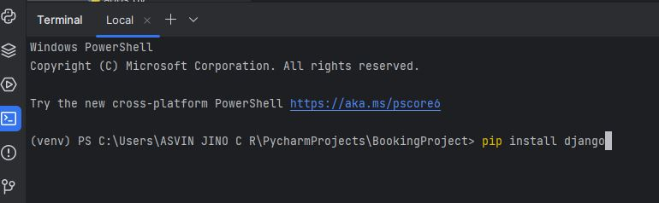

* Create myproject and myapp

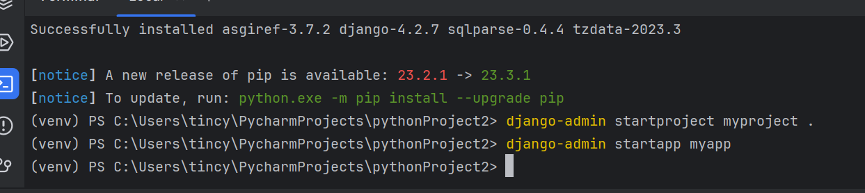

**PROGRAM FILES**

**Settings.py**

In Django, the settings.py file is a crucial part of this project configuration. It contains various settings that control how Django project behaves.

1. Installed Apps:

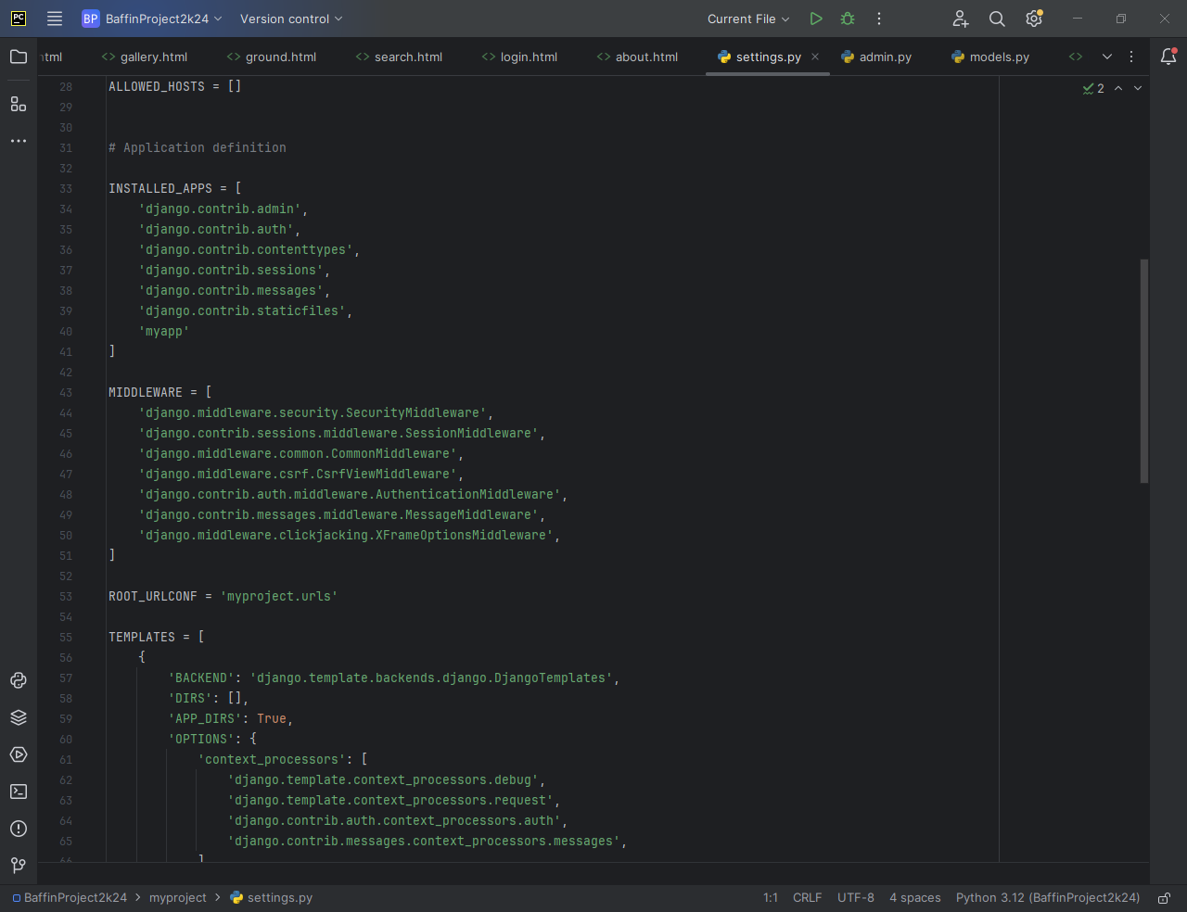

**Myproject/urls.py**

It is used to define the URL patterns and routes for this application. It plays a crucial role in directing incoming HTTP requests to the appropriate view function.

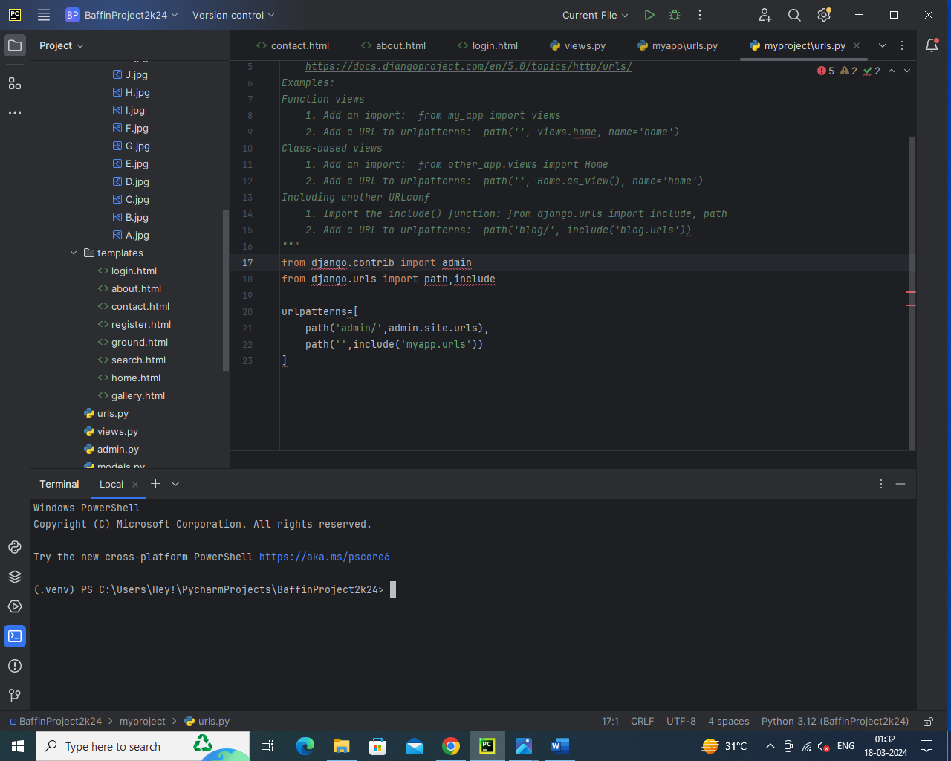

**myapp/urls.py**

In Django each app has its own urls.py file to define URL patterns specific to that app. This allows to organize and encapsulate the URL routing for different parts of application.

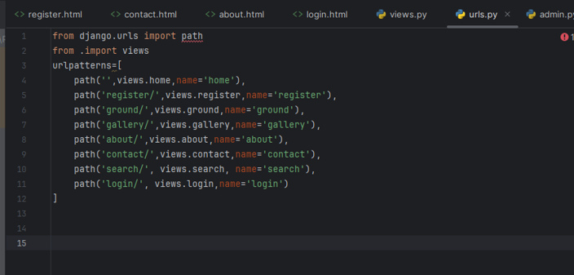

**Views.py**

View functions that handle incoming HTTP requests and return HTTP responses. It is responsible for processing data, interacting with models, and redering templates to generate the final response that is sent back to the client.

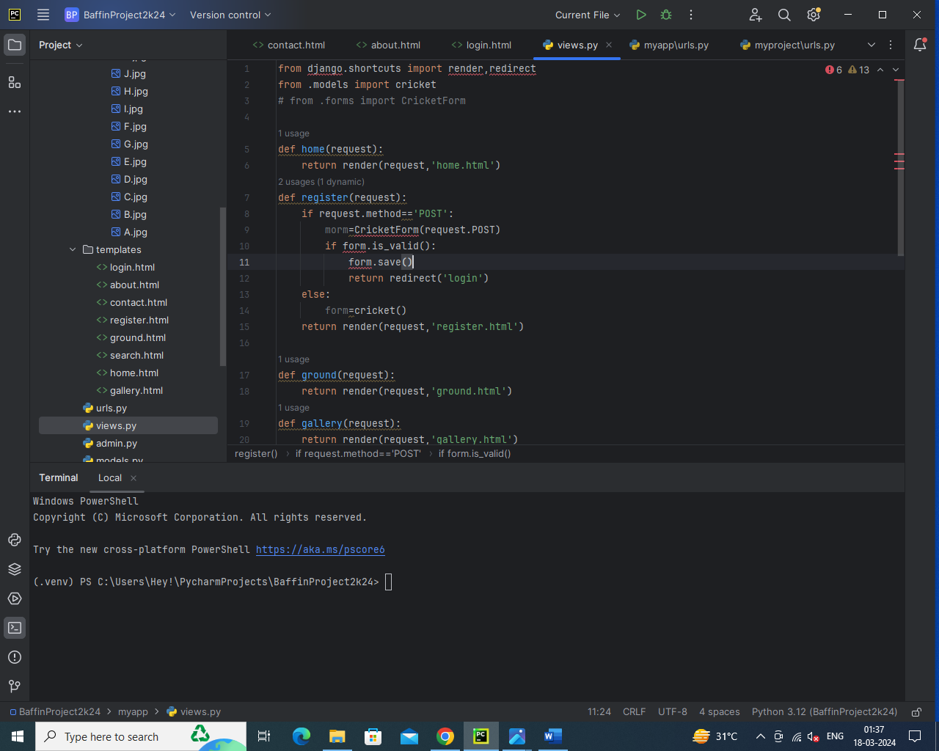

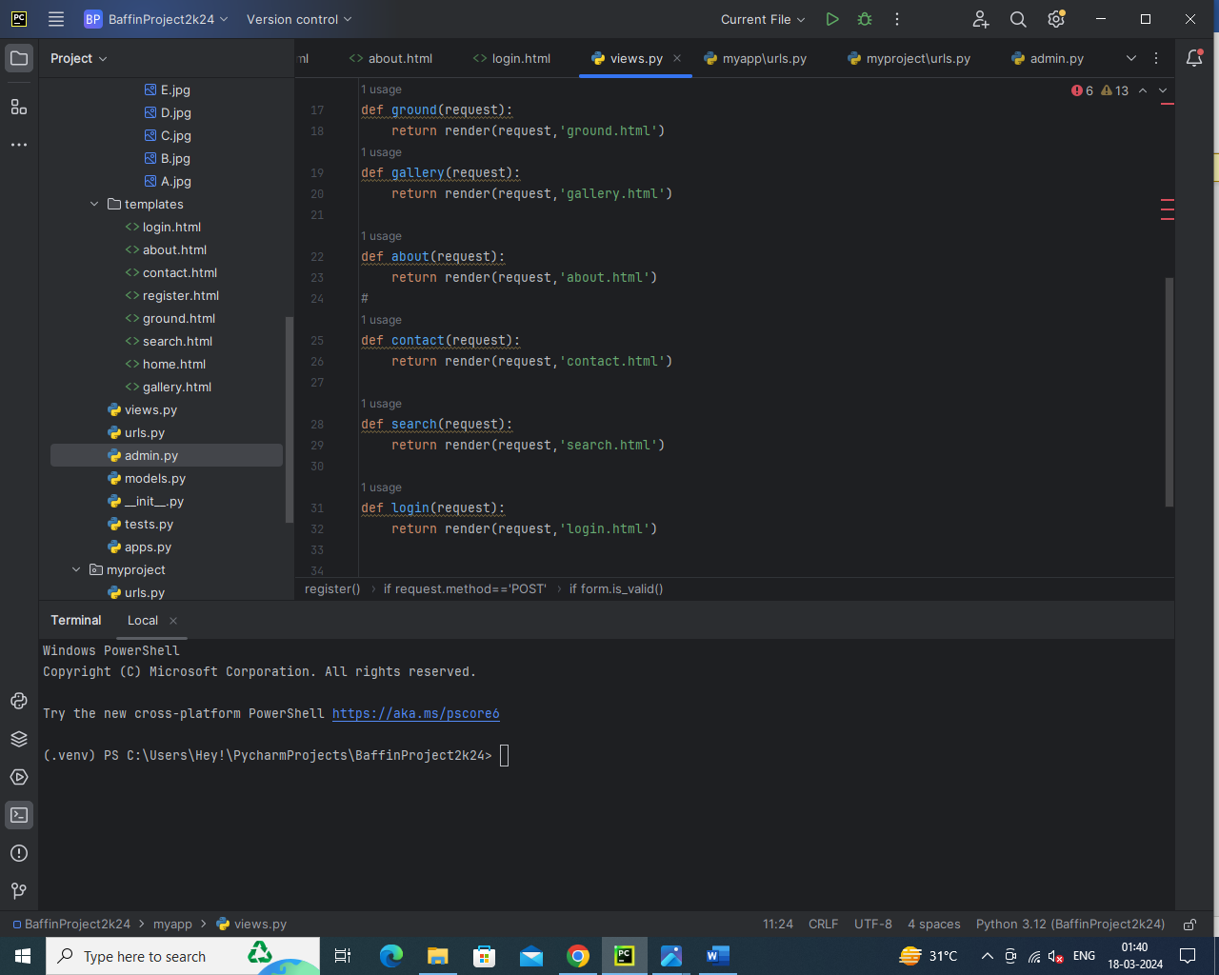

**models.py**

Django web applications access and manage data through Python objects referred to as models. Models define the structure of stored data, including the field types and possibly also their maximum size, default values, selection list options, help text for documentation, label text for forms, etc.

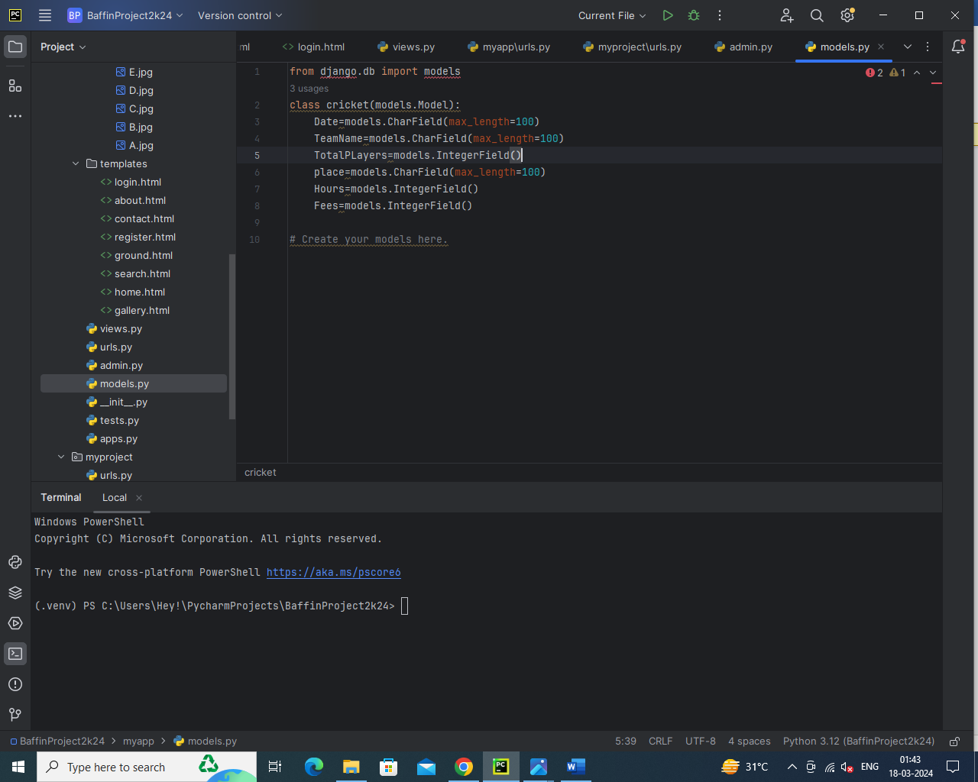

**admin.py**

It is used to customize the Django admin interface for your models. This is where we can define how the models are displayed and edited in the admin interface.

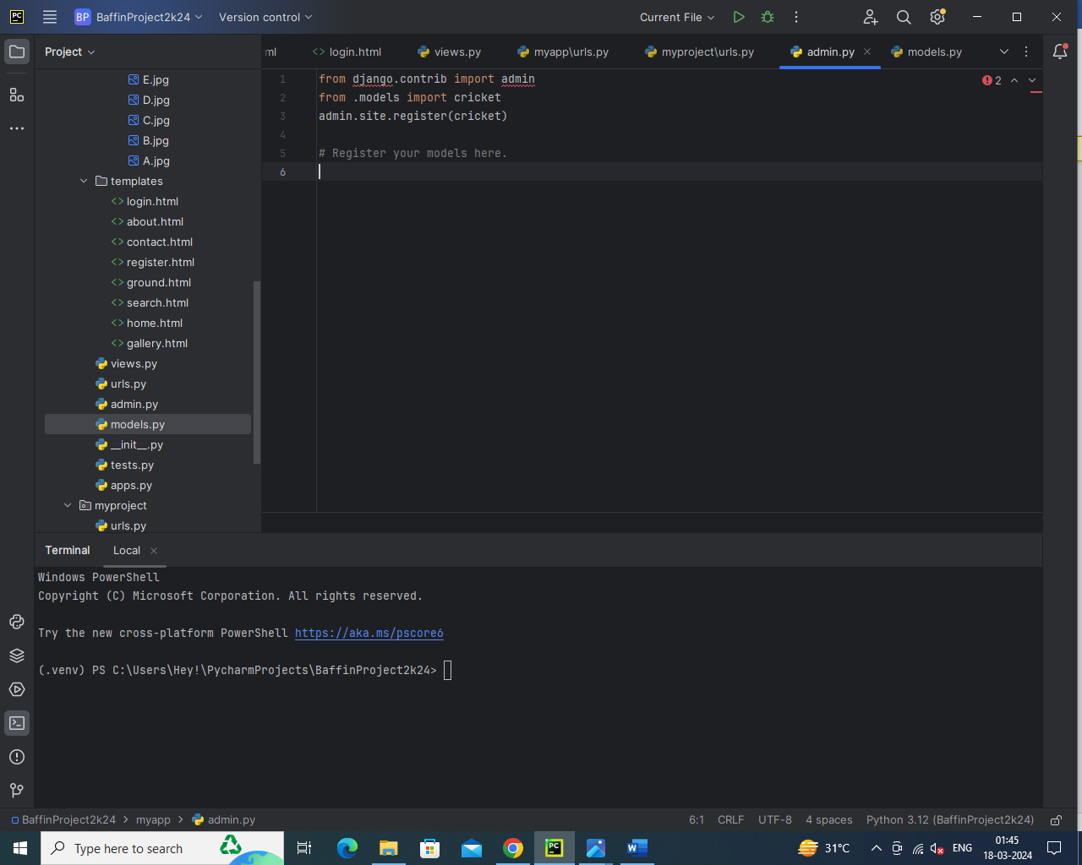

**Create Templates and Static**

* Create Image files and JavaScript files in Static file.
* Create Html files in templates.

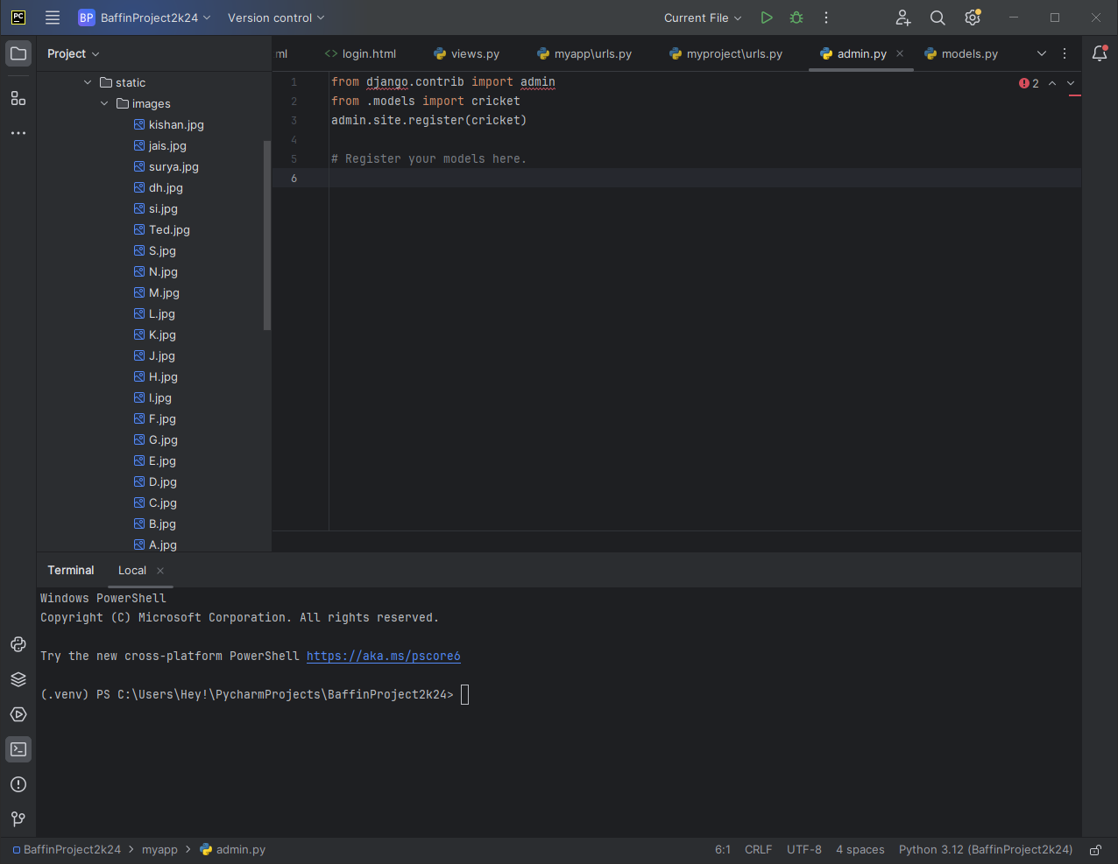

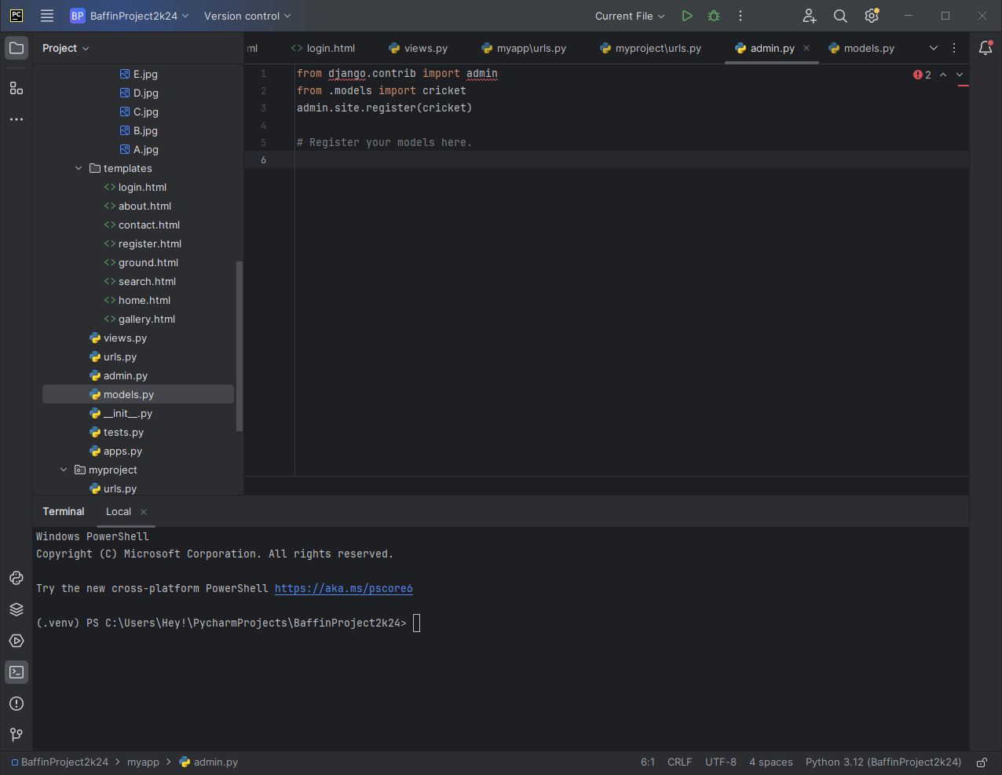

**1.home.html:**

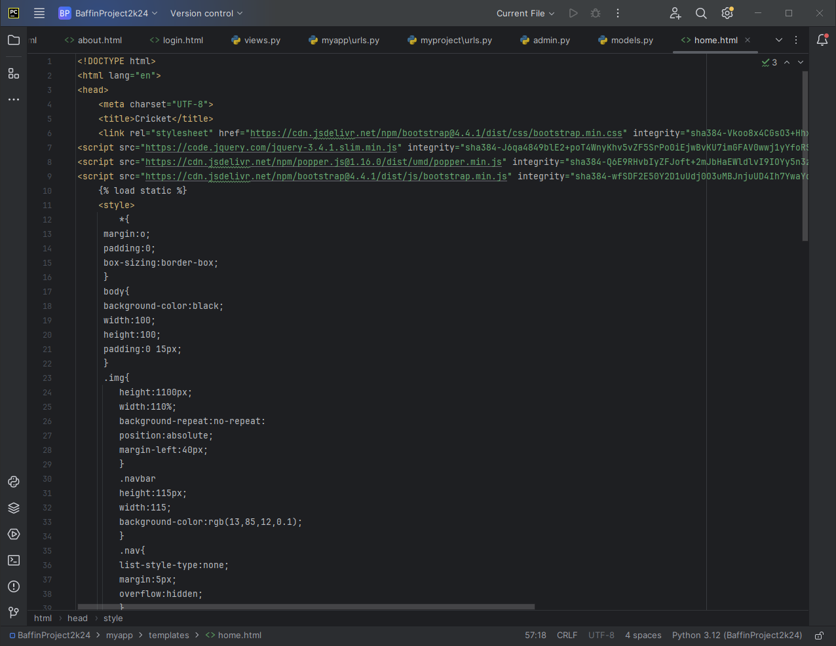

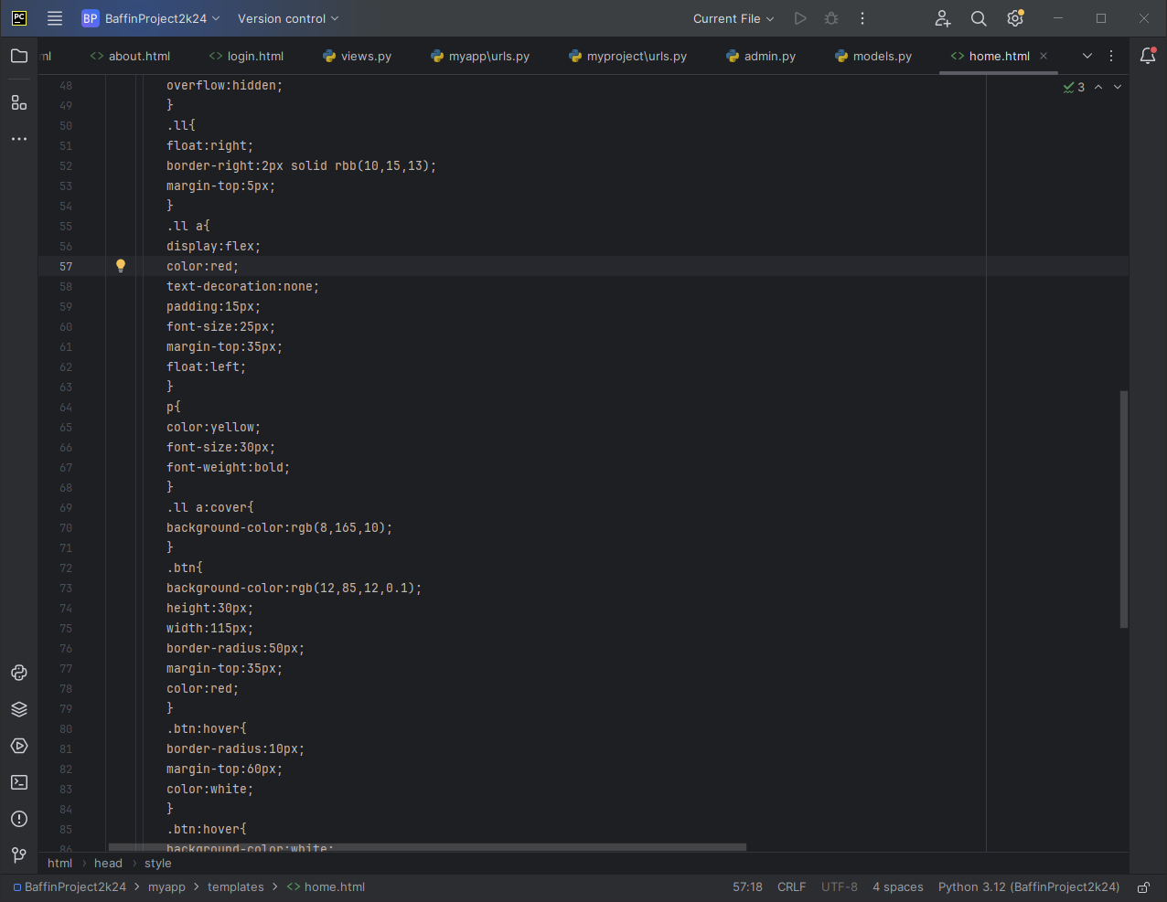

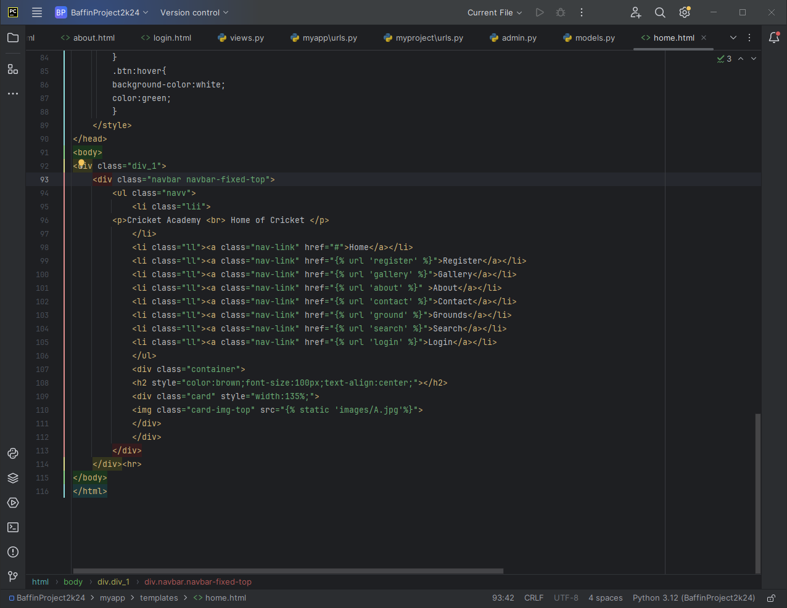

**2.Register.html:**

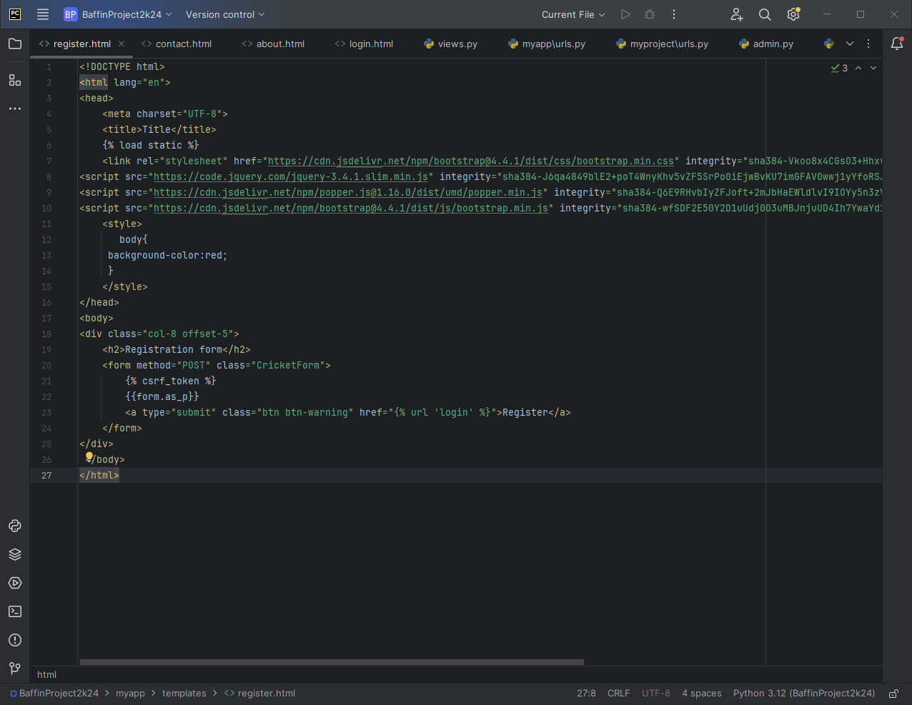

**3.Contact.html:**

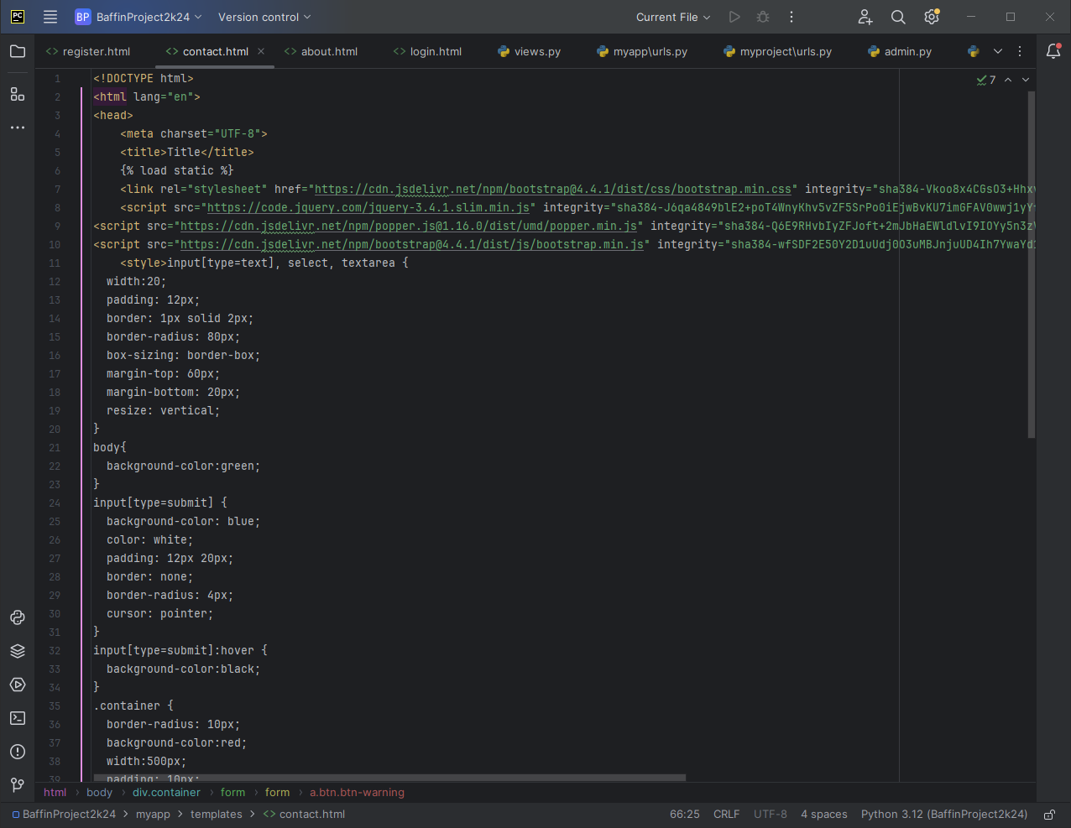

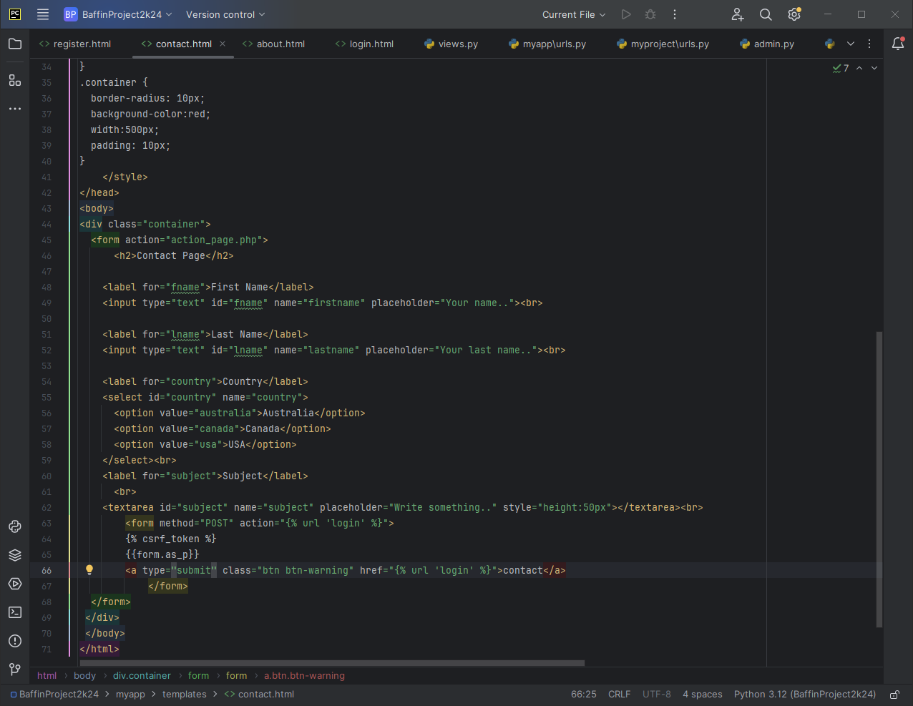

**4.Gallary.html:**

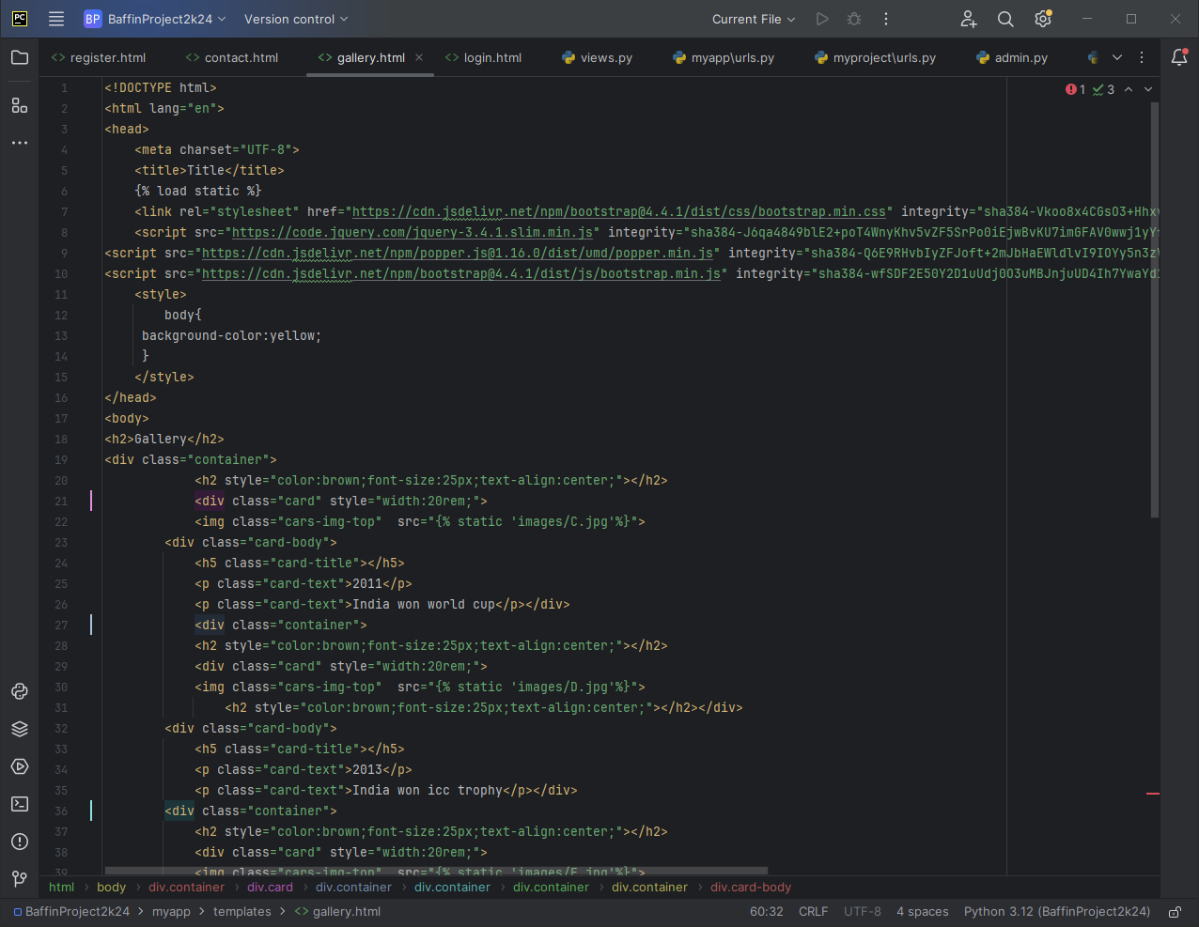

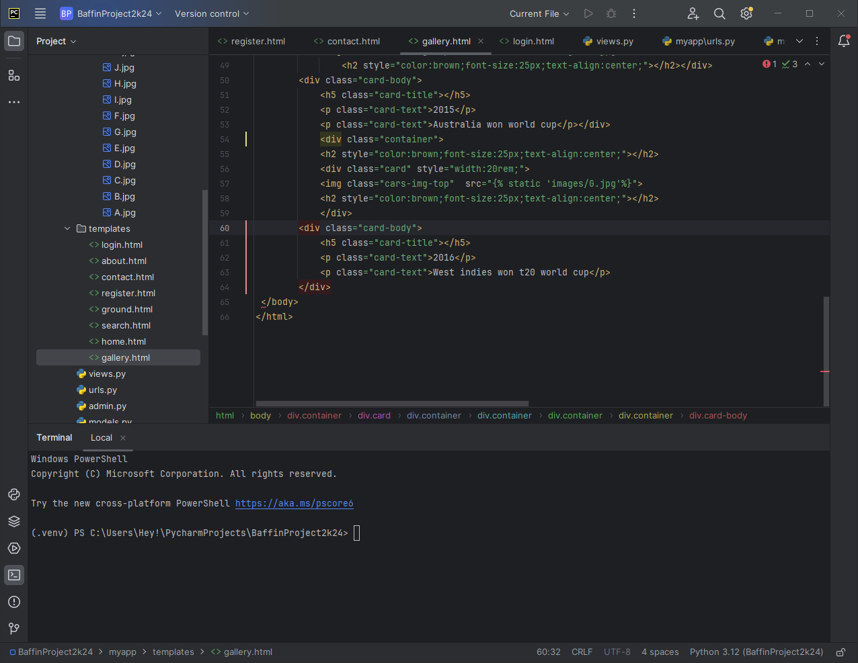

**5.Ground.html:**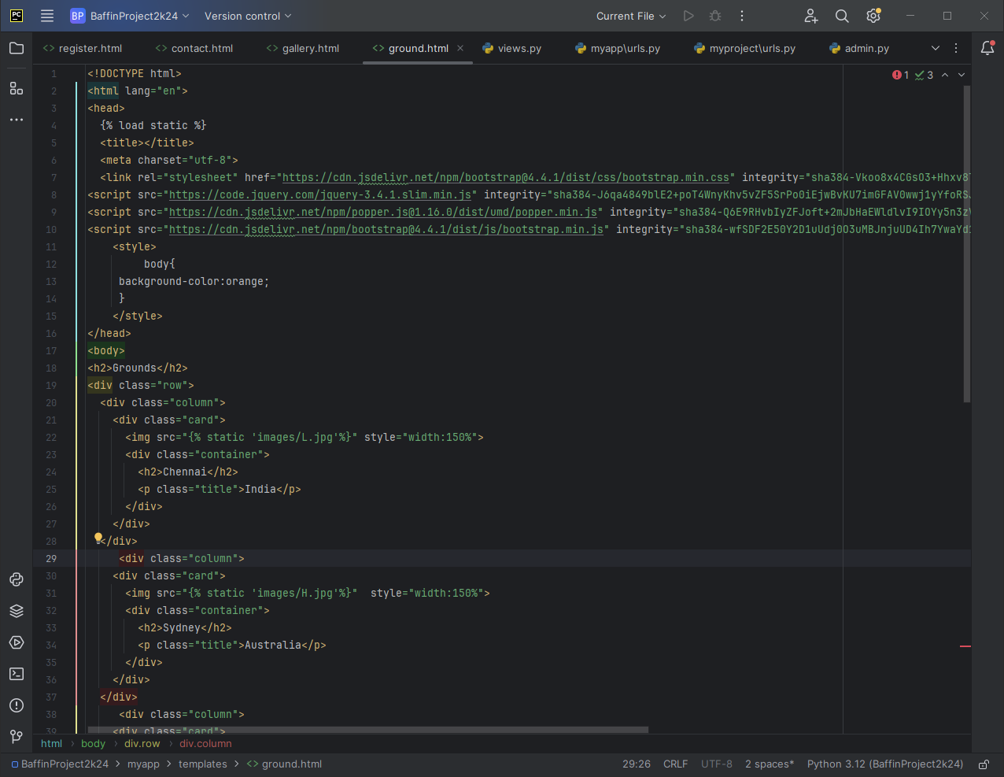

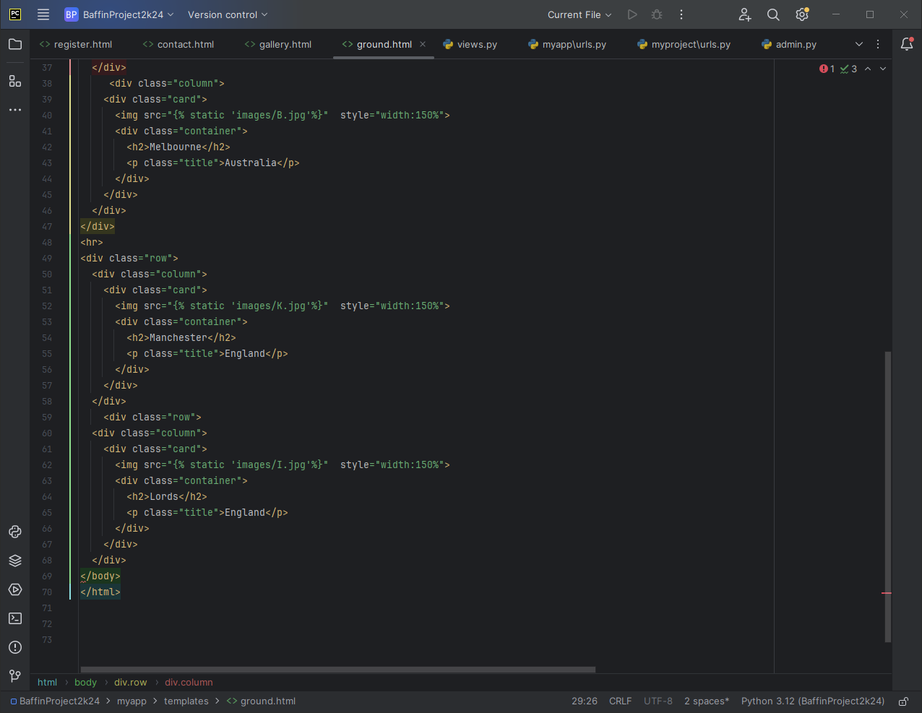

**6.search.html:**

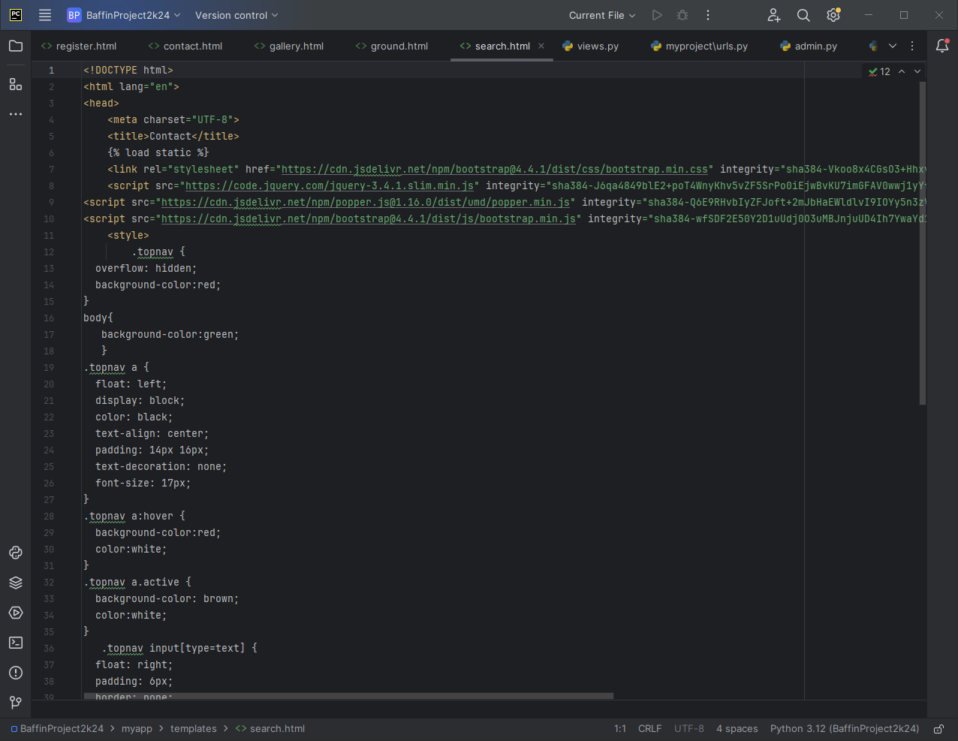

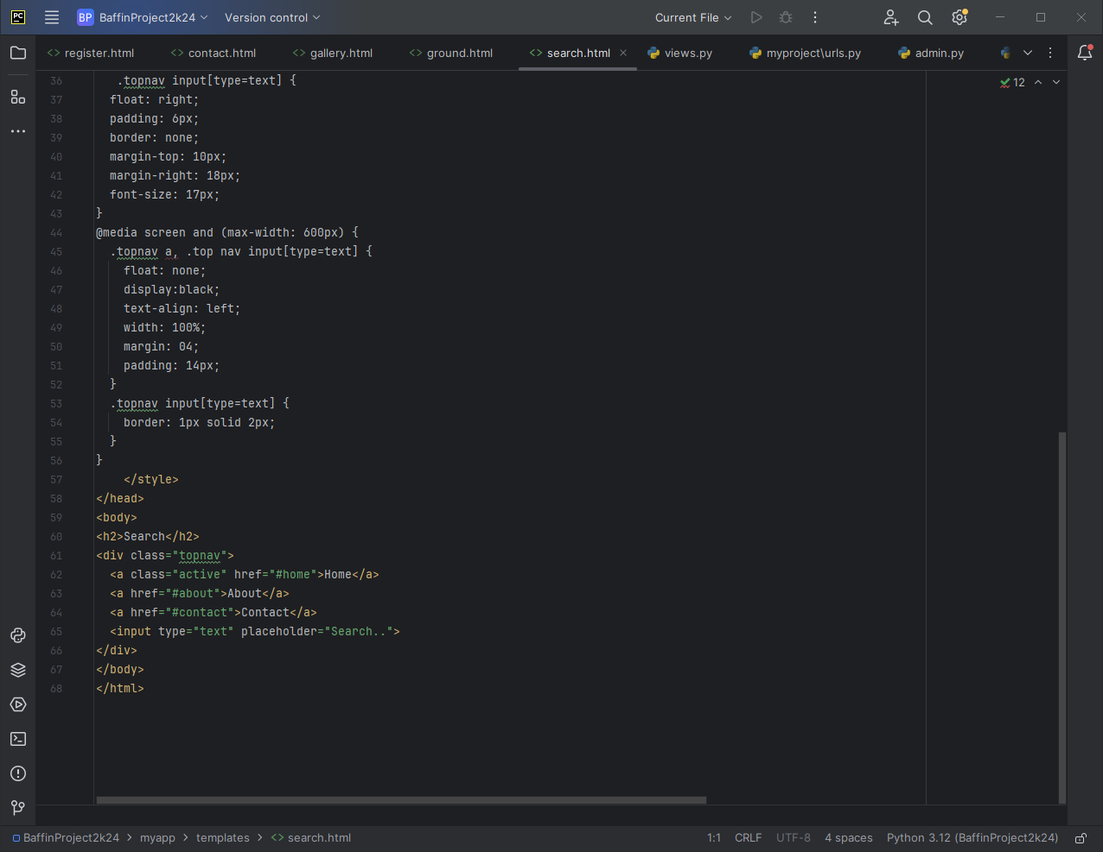

**7.login.html:**

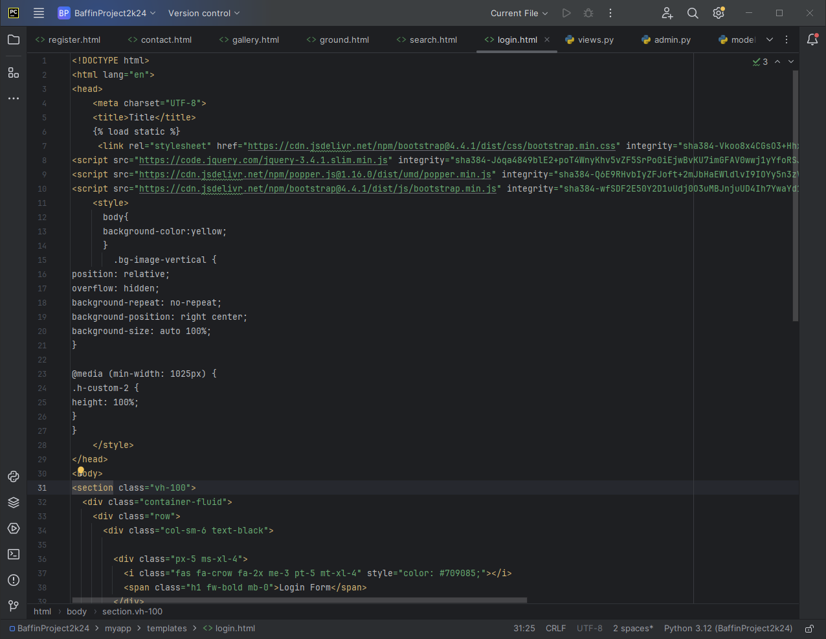

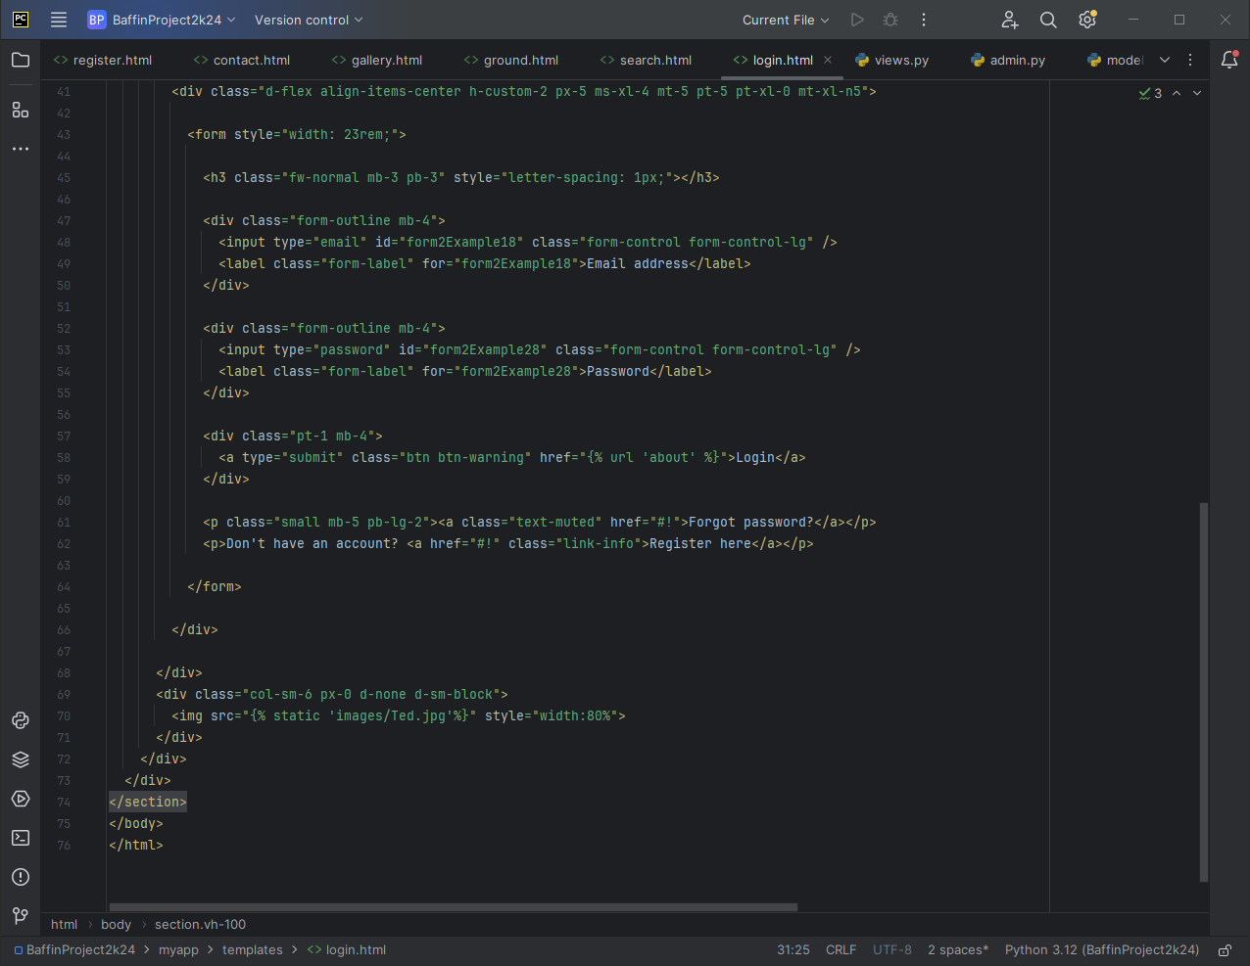

**8.about.html:**

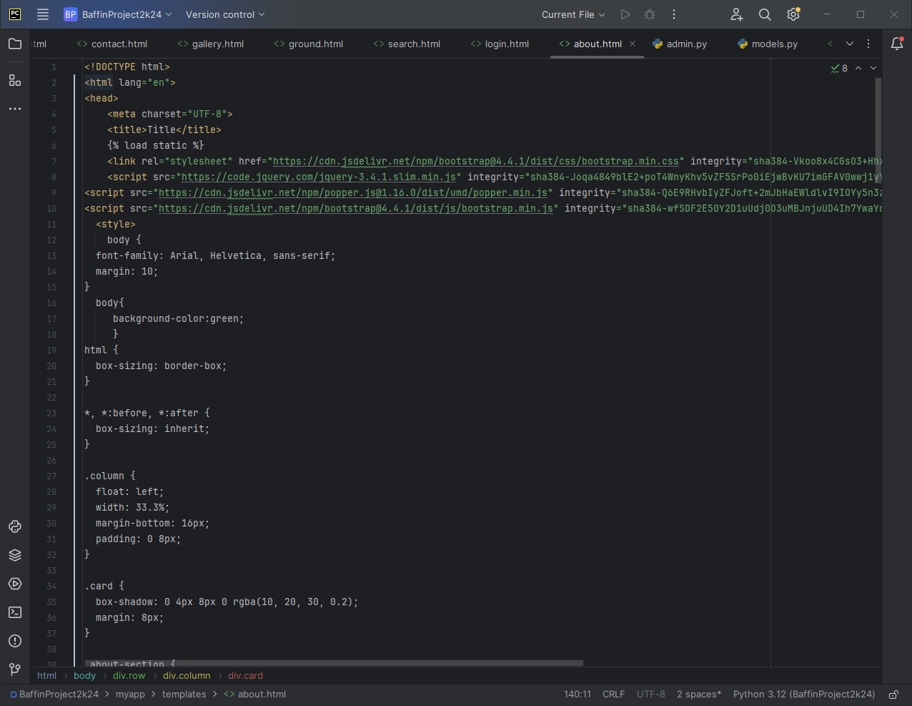

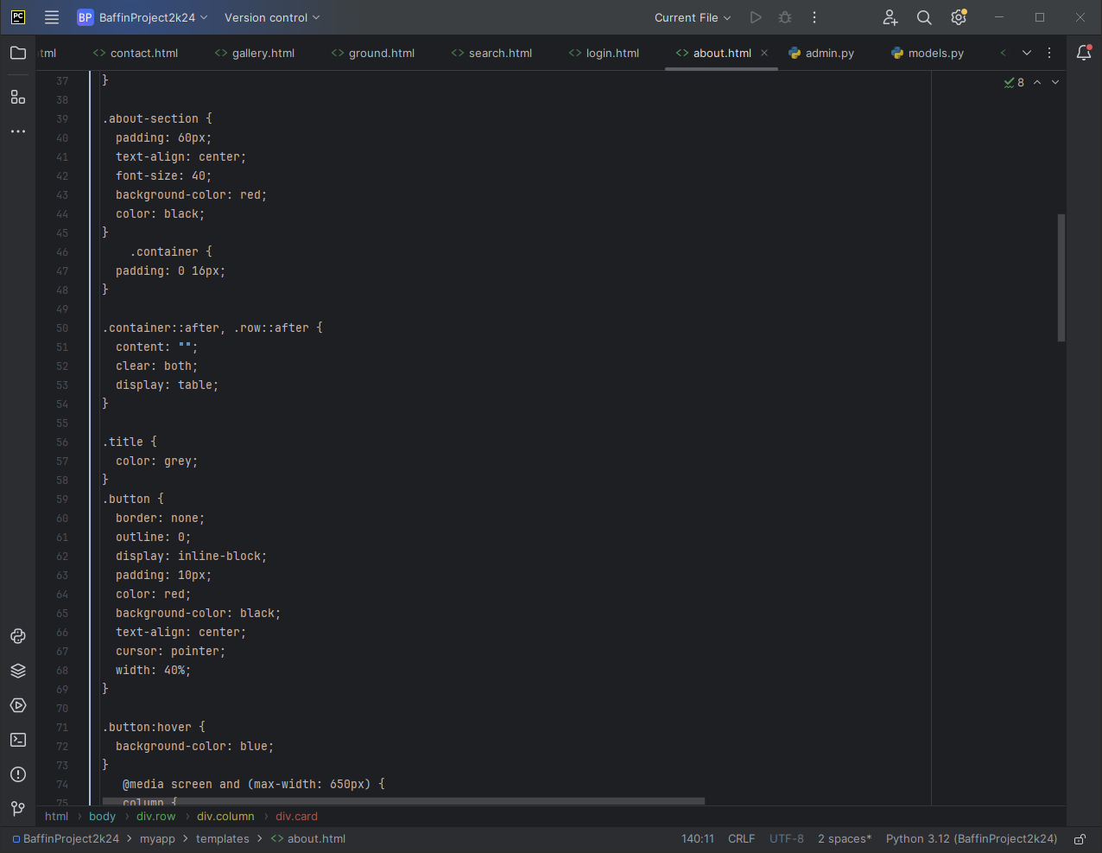

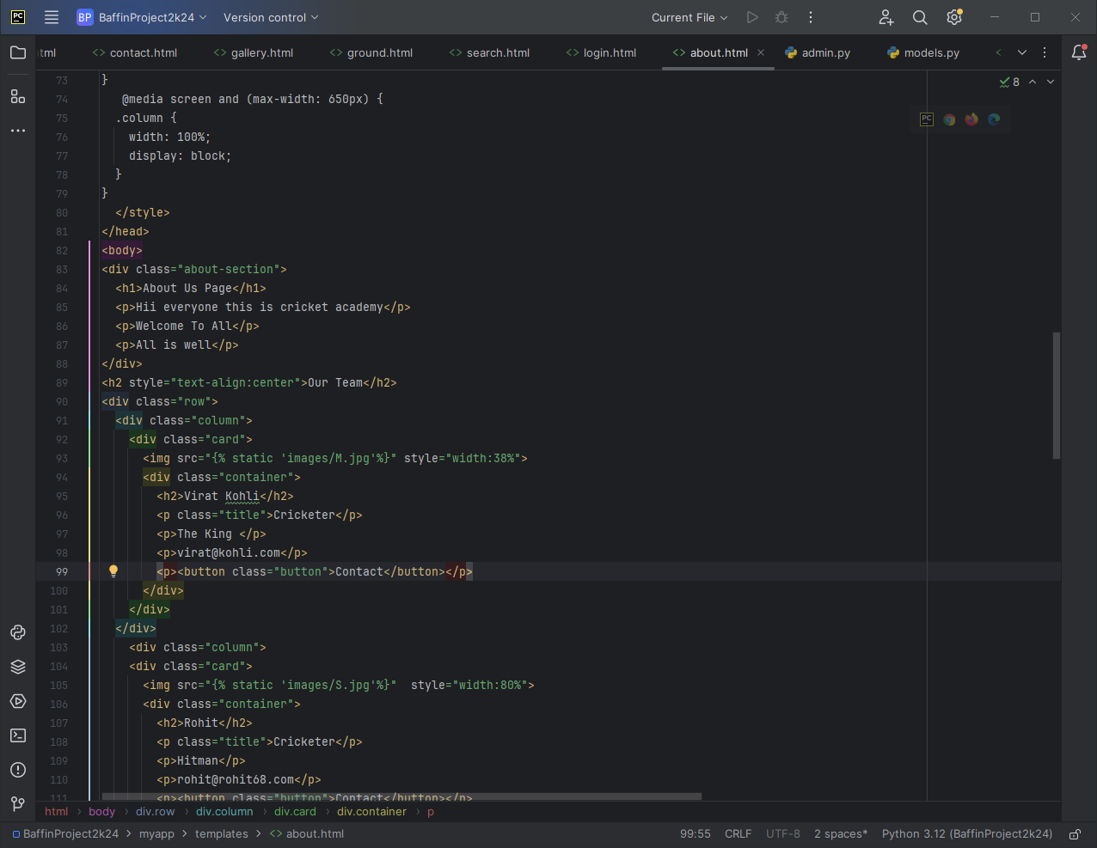

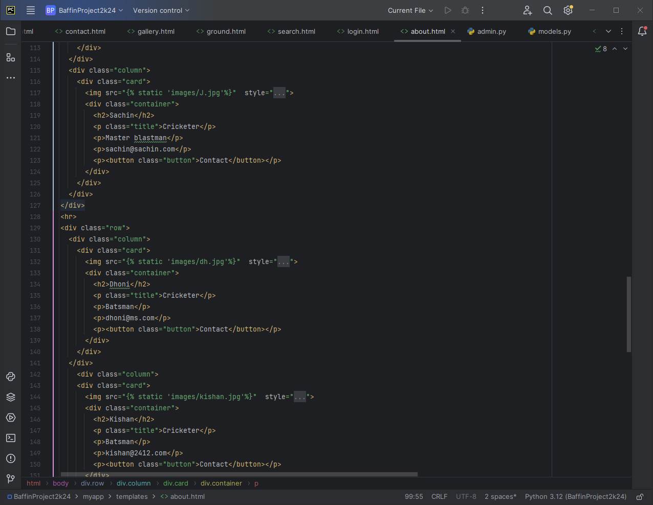

**Output**

**View of Cricket Academy**

**Home page:**

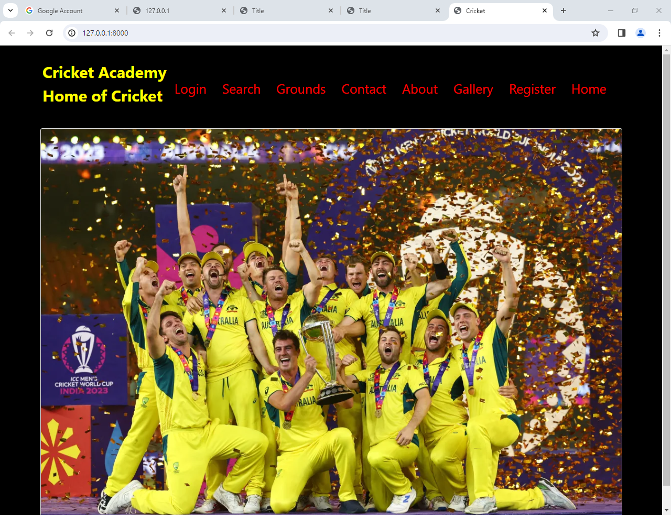

**Contact Page:**

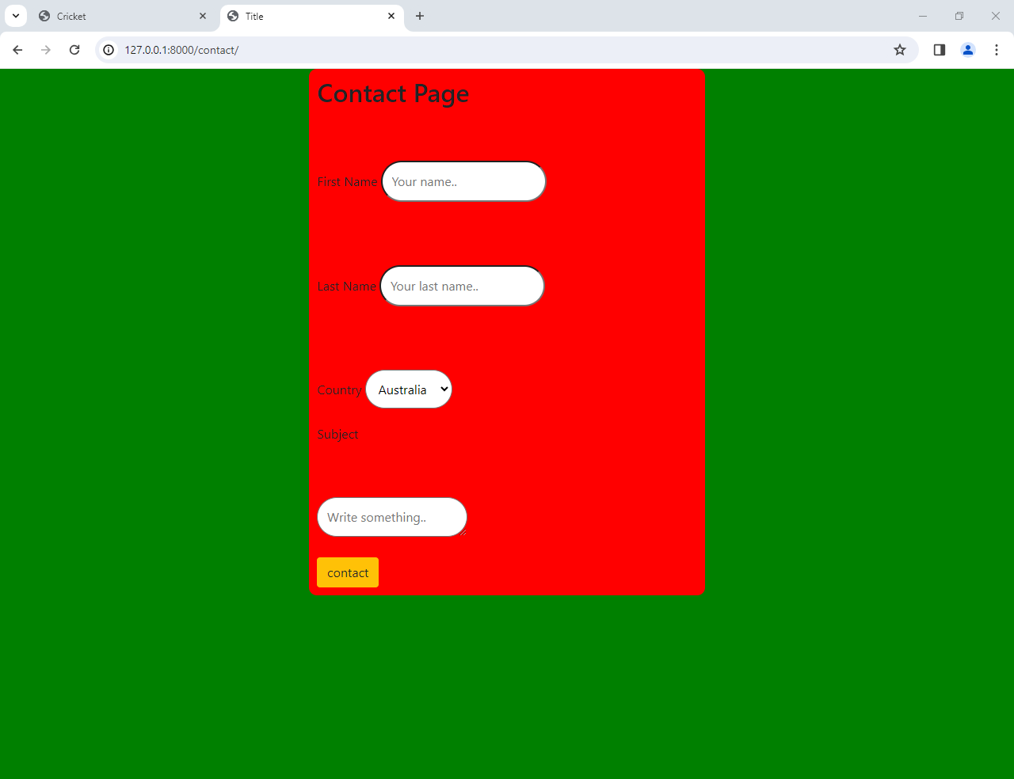

**Gallery page:**

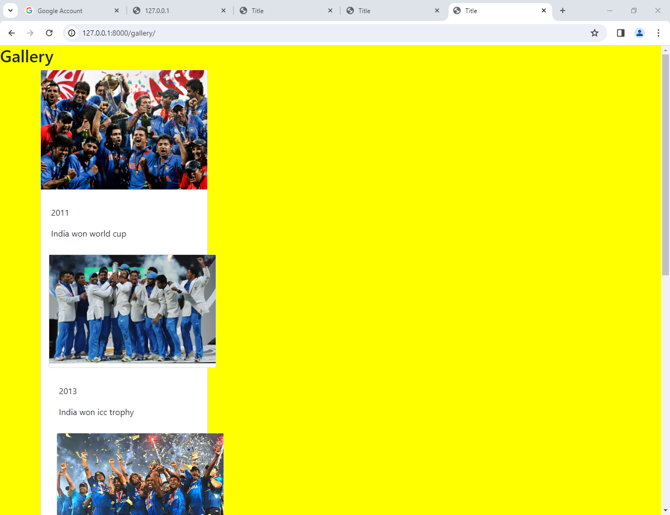

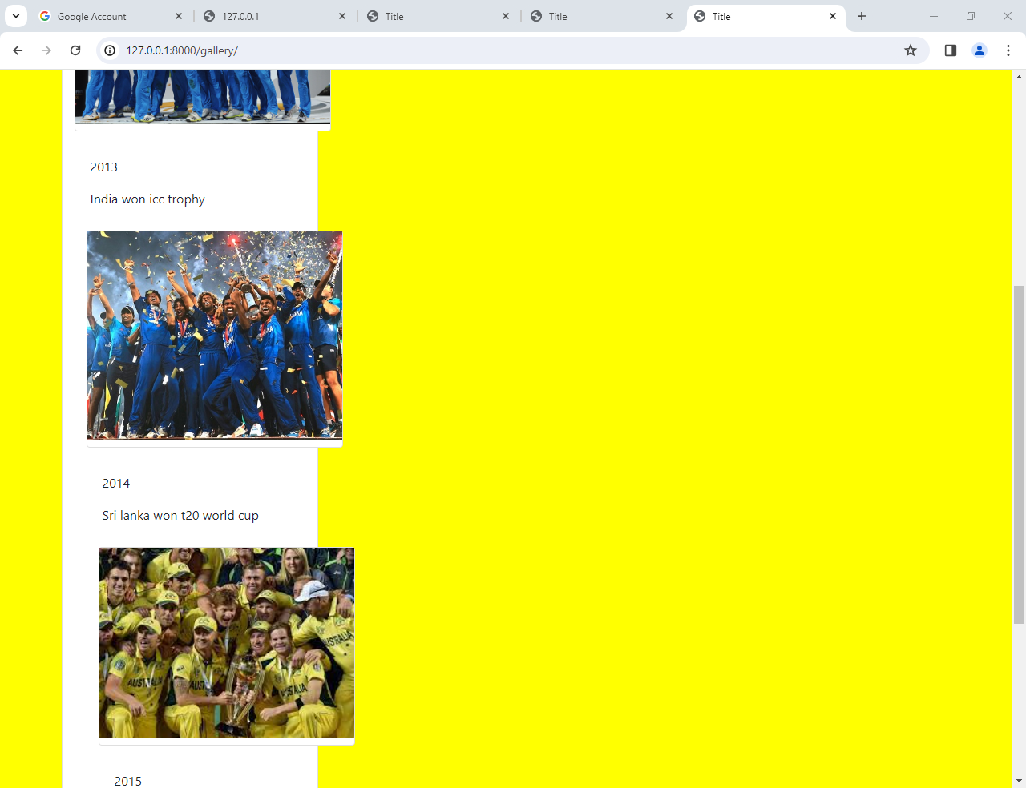

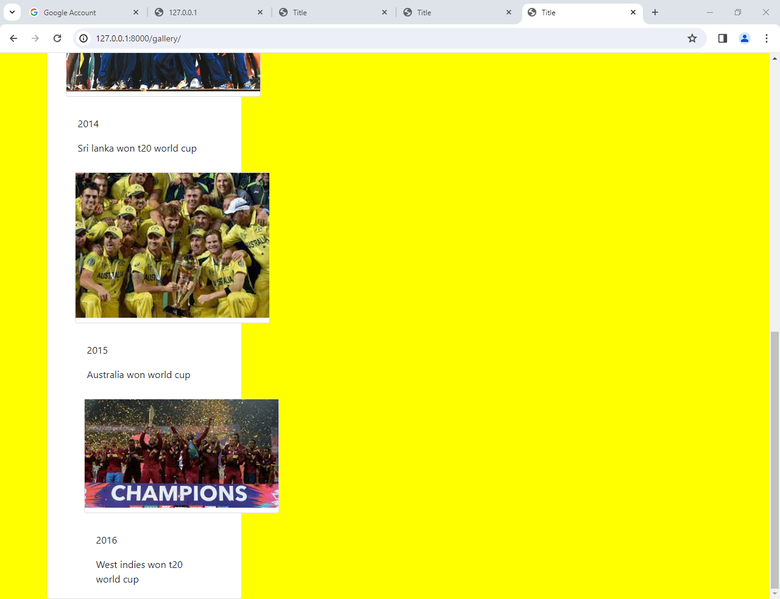

**Grounds page:**

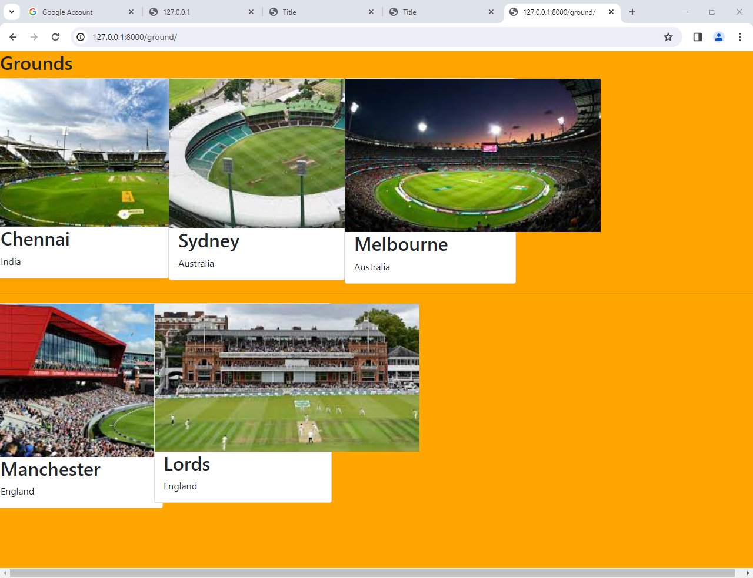

**Search Page:**

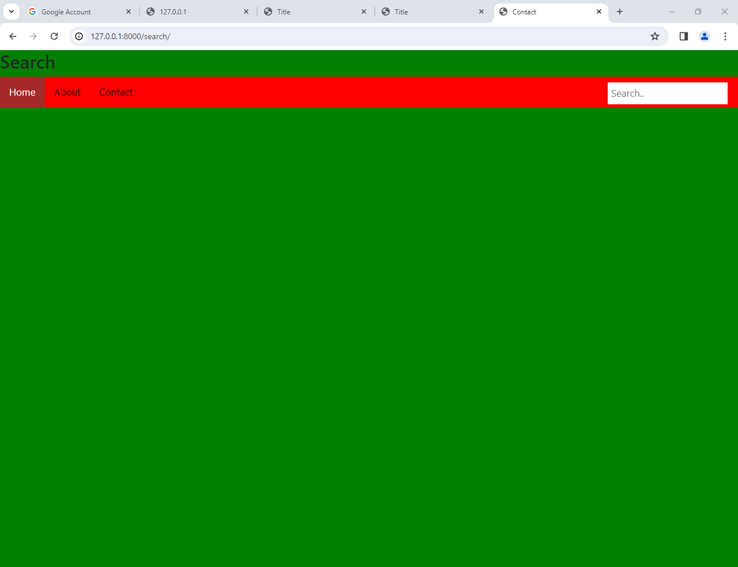

**Login page:**

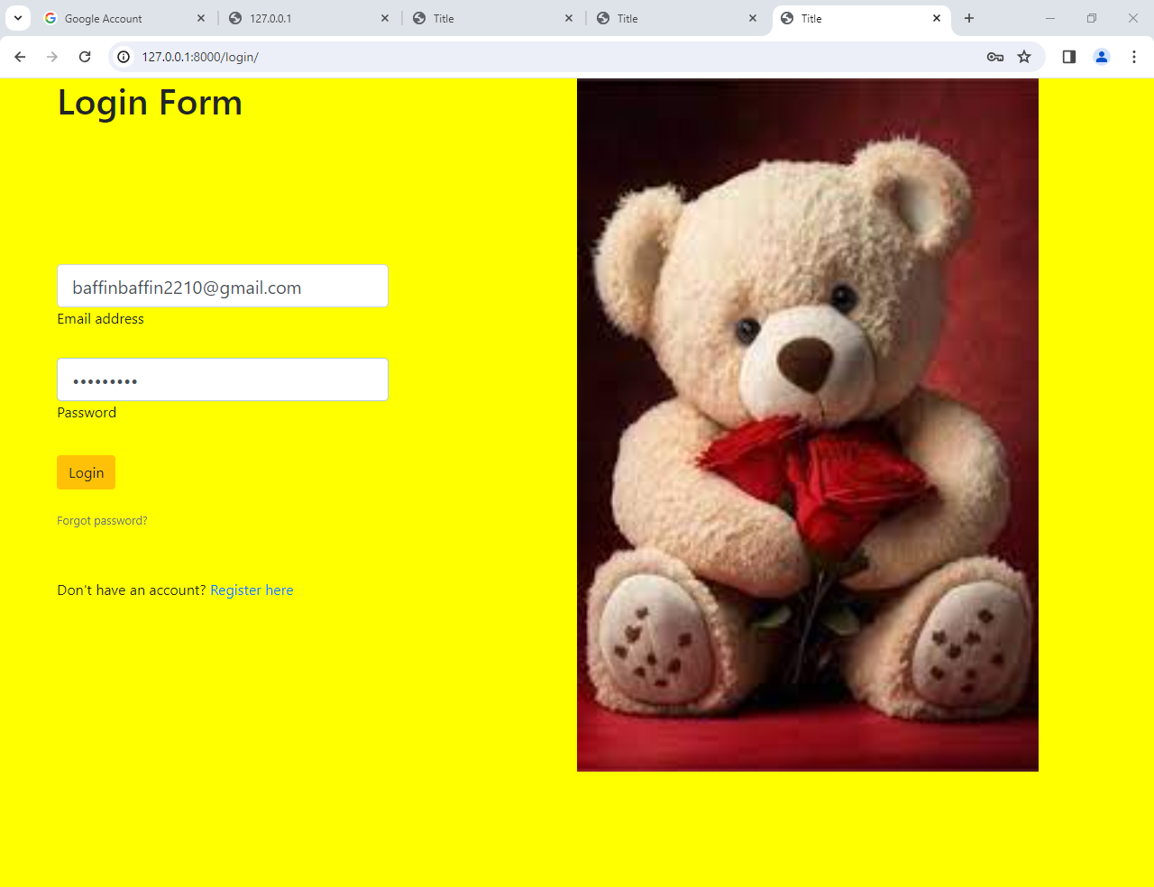

**About Page:**

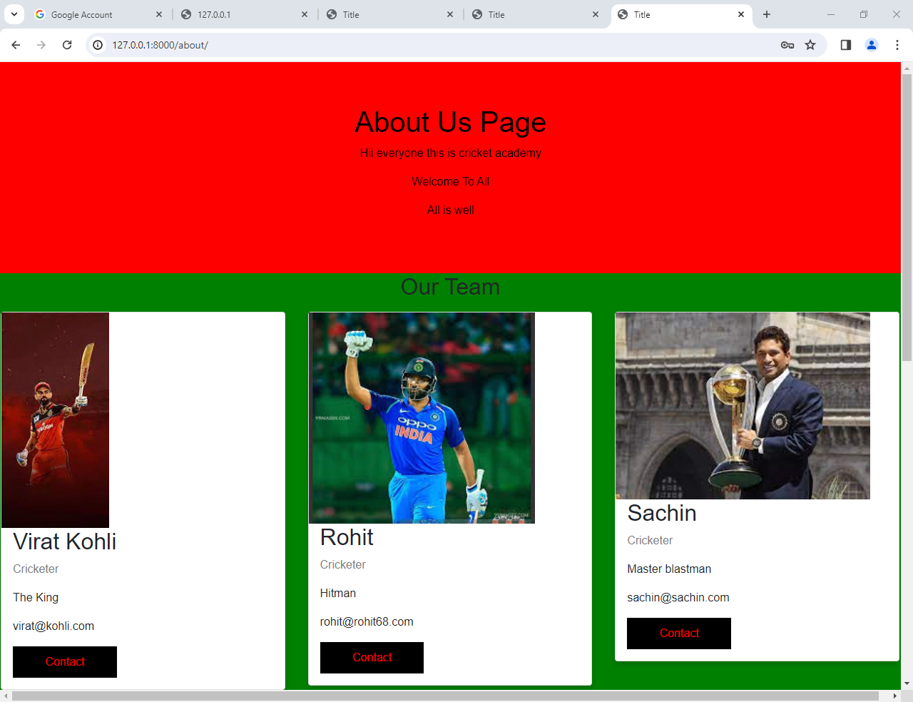

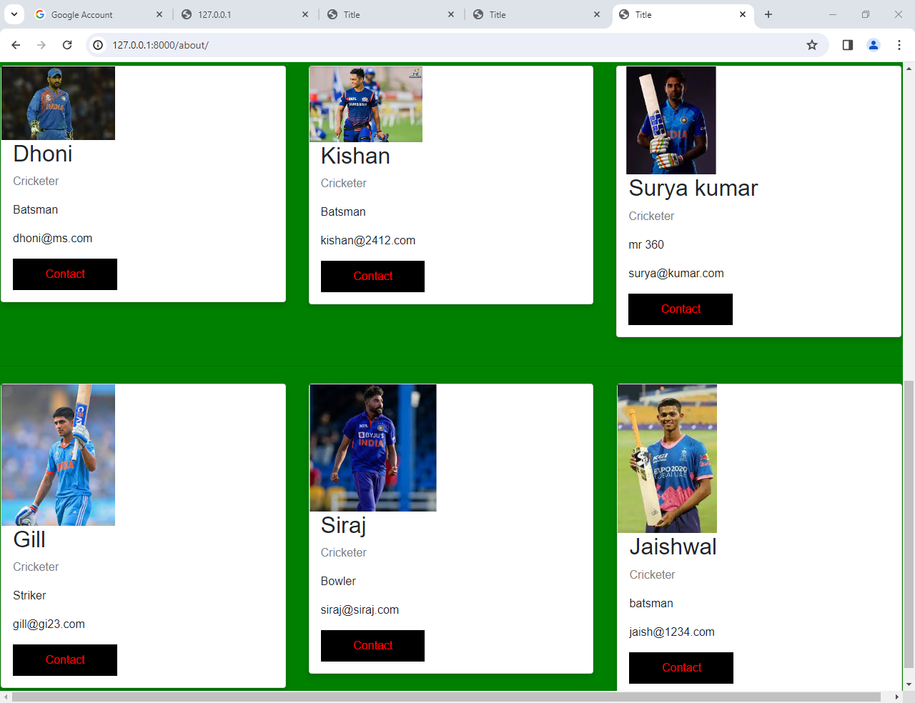

**Register page:**

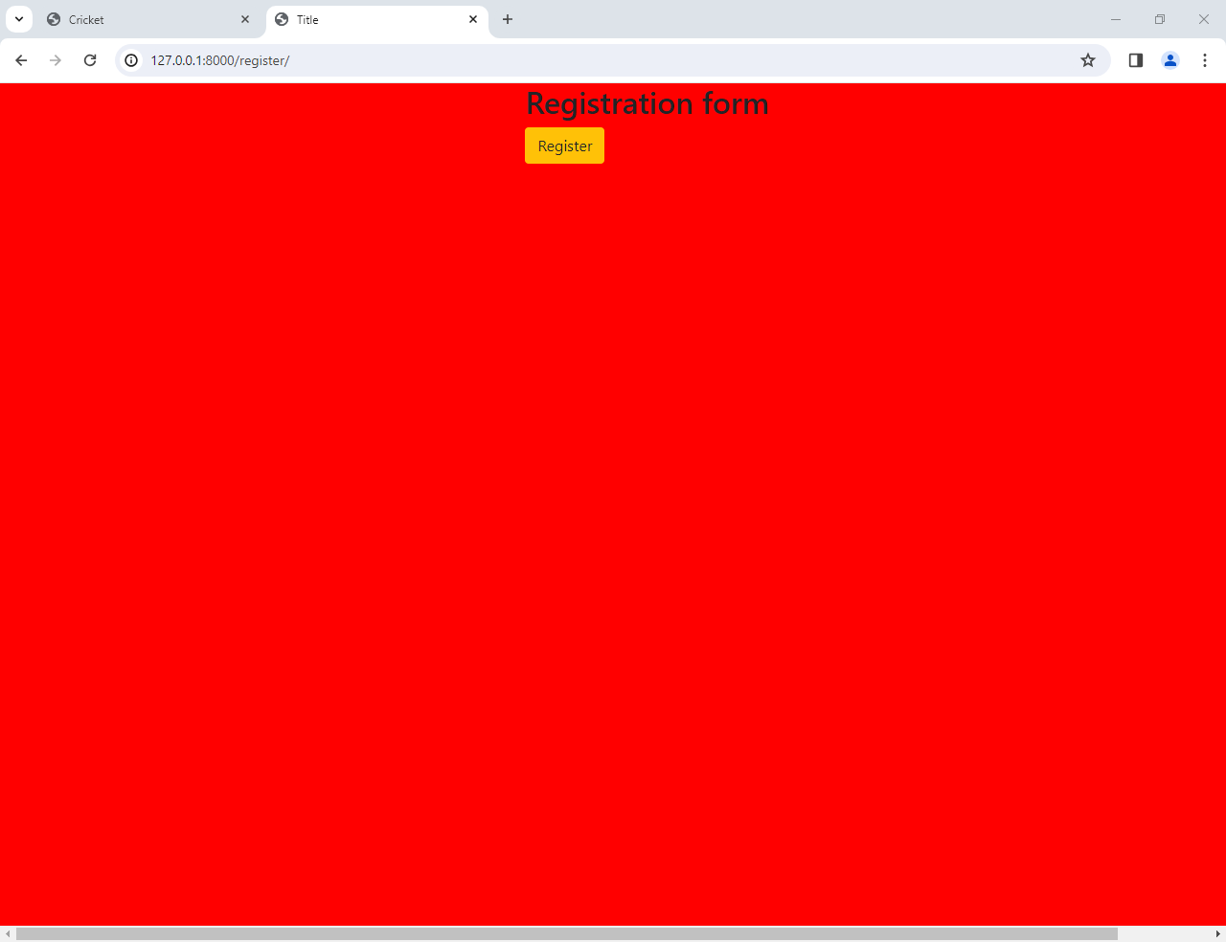

**Django administration and DB-browser**

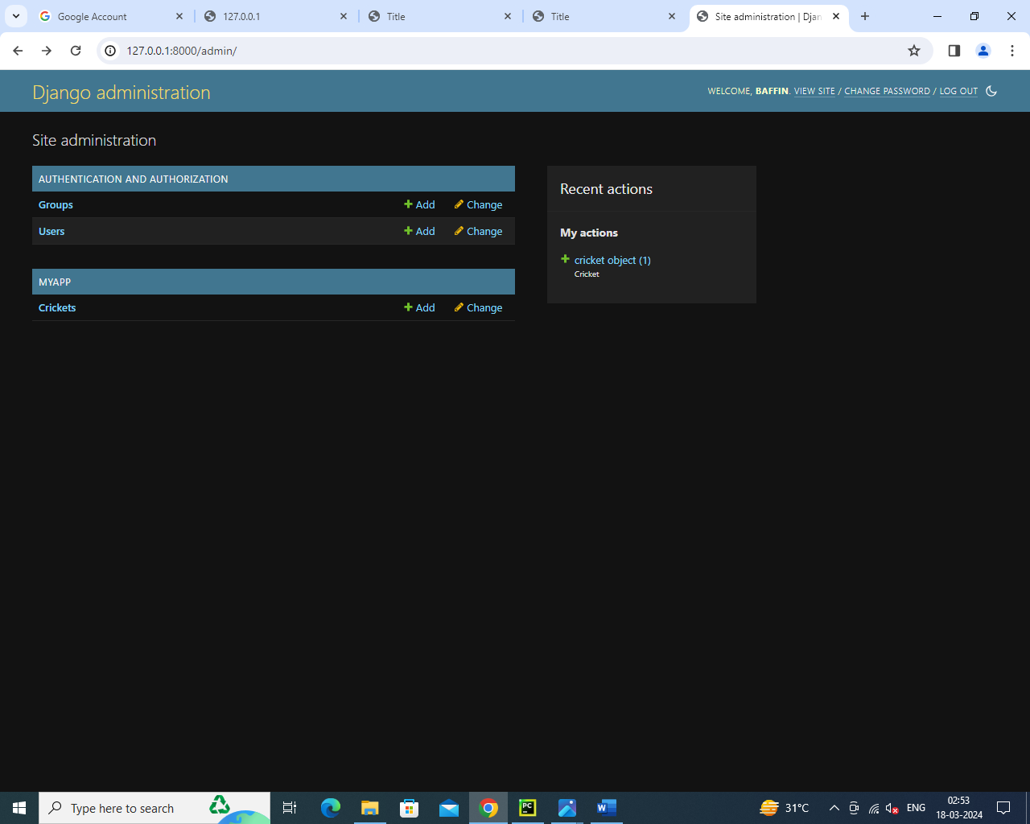

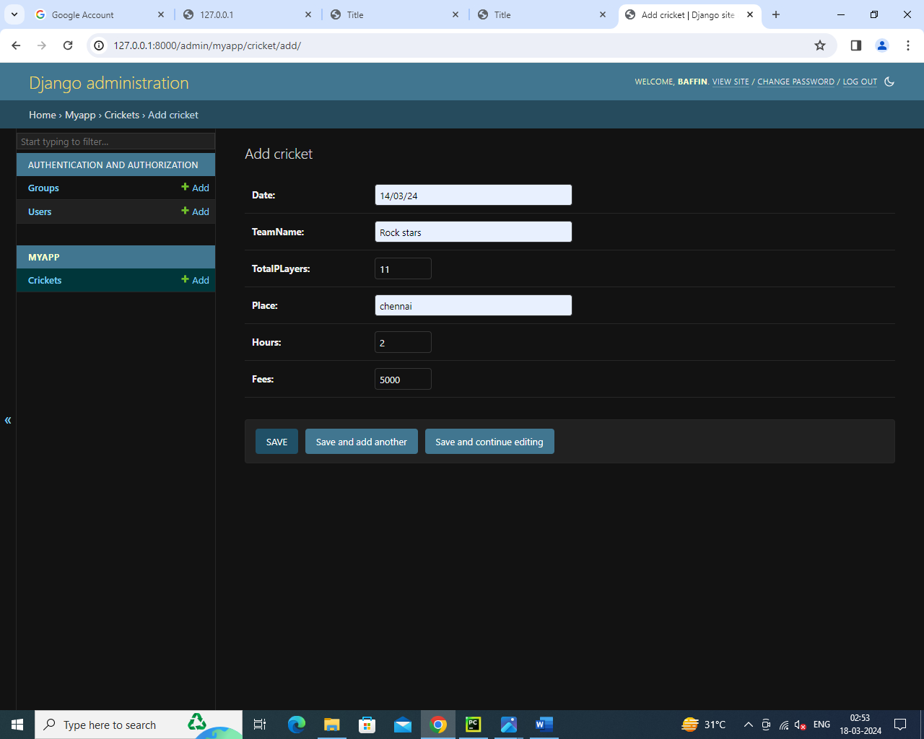

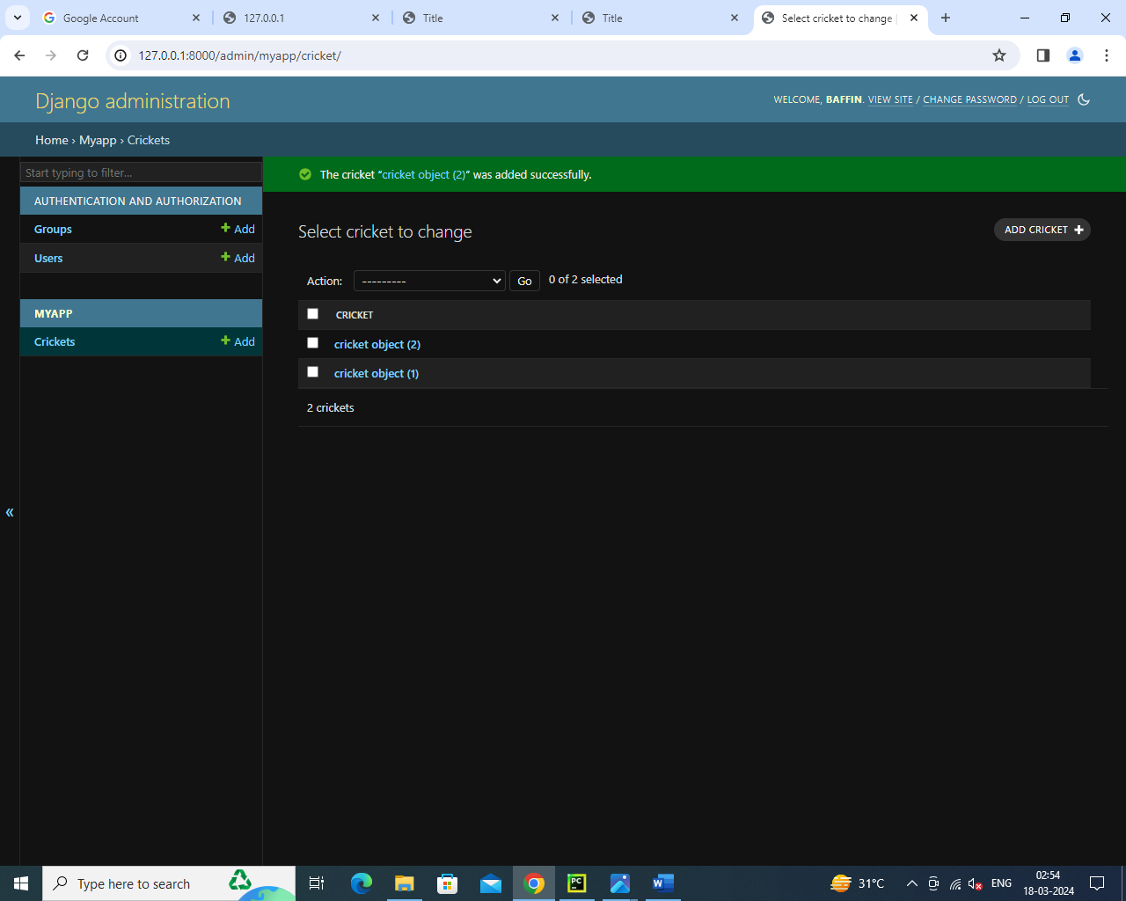

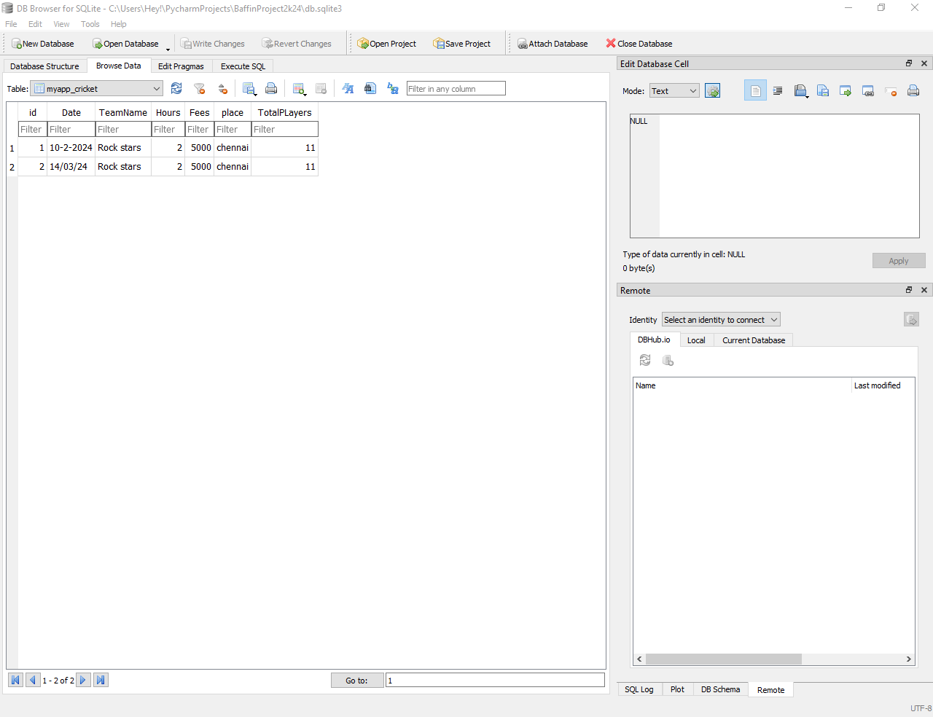

**Conclusion:**

The creation of cricket academy website using Django presents an exciting opportunity to develop a robust and user-friendly platform for event organizers and attendees. Leveraging the power of the Django frame work, this project aims to streamline the entire cricket academy and registration.

The website, built on Django’s foundation, incorporates essential features such as user registration, event booking and also user send messages to cricket academy.

As the development progresses, considerations for security, data privacy, and user experience. the Django framework, I have successfully accomplished the requirements of the system. Once this system passes the testing phase, it can be used to serve peoples and instructors. It may still encounter problems during real time use. However, even if that happens, the flexibility of Django would provide a simple way to fix the problem, as well as add new features into the system.

Thank You.